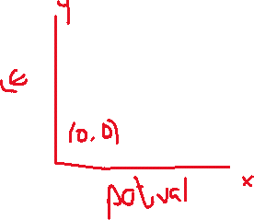

(0, 0)

(1023, 255)

M = (y2 -y1)/ (x2-x1)

M = (LED2-LED1)/(potVAL2-potVAL1)

= (255-0)/(1023-0)

=